SQL CLASS -

TOPICS – Joins- Inner, Outer, Equi, Self, Cross, Natural

Joins –

- Join is used to combine data from two or more tables based on values of the related columns tables to form a single result set.
- The related columns are typically the primary key column(s) of the first table and foreign key column(s) of the second table.
- The tables to be joined are listed in the FROM clause and the join conditions are defined in the WHERE clause.

Guidelines –

- When writing a SELECT statement that uses joins, provide the column name with the table name for clarity.
- If the same column name appears in more than one table, the column name must be prefixed with the table name or give table name an alias and provide that alias to the columns.
- To join ‘n’ tables together, you need a minimum of n-1 join conditions.

Types of Joins –

- Inner Joins (Simple Join)
- Outer Joins
- Left Outer Join (Left Join)
- Right Outer Join (Right Join)
- Full Outer Join (Full Join)
- Equijoins
- Self-Join
- Cross Join (Cartesian Products)
- Natural-join

- Inner Join (Simple Join) -

- INNER JOINS return all rows from multiple tables where the join condition is met.
- The inner join returns rows from the left table that match with the rows from the right table.
- For the Inner join, the condition in the ON clause is equivalent if it is placed in the WHERE clause.
- The INNER keyword is optional.
- Inner join can have equality (=) and other operators (like <, >, <>) in the join condition.

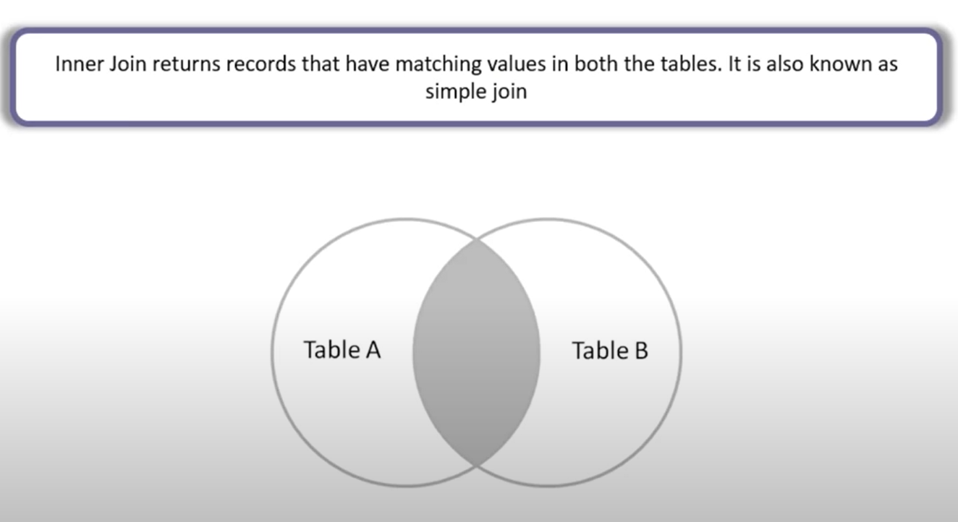

Syntax -

SELECT a.column_name, b.column_name
FROM table_name a INNER JOIN table_name b
ON a.column_name = b. Column_name;

OR

SELECT a.column_name, b.column_name
FROM table_name a, table_name b
WHERE a.column_name = b. Column_name;

OR

SELECT column_name, column_name
FROM table_name INNER JOIN table_name
USING (common_column_name);

Example -

CREATE TABLE emp_log(
emp_id NUMBER PRIMARY KEY,
name VARCHAR2(100)
);

CREATE TABLE emp_details(
emp_id NUMBER PRIMARY KEY,
address VARCHAR2(100),
address_code NUMBER
);

CREATE TABLE address_code_name(
add_code NUMBER PRIMARY KEY,
add_code_name VARCHAR2(100)
);

INSERT INTO emp_log VALUES (1,'John');
INSERT INTO emp_log VALUES (2,'Lilly');
INSERT INTO emp_log VALUES (3,'Peter');
INSERT INTO emp_log VALUES (4,'Roy');
INSERT INTO emp_log VALUES (8,'Nick');
INSERT INTO emp_log VALUES (9,'Sam');
INSERT INTO emp_log VALUES (10,'Rock');

COMMIT;

INSERT INTO emp_details VALUES(1,'India',4444);
INSERT INTO emp_details VALUES(2,'USA',5555);
INSERT INTO emp_details VALUES(3,'Russia',6666);
INSERT INTO emp_details VALUES(4,'South Africa',7777);
INSERT INTO emp_details VALUES(5,'Uk',8888);
INSERT INTO emp_details VALUES(6,'Brazil',9999);
INSERT INTO emp_details VALUES(7,'New Zealand',2222);
INSERT INTO emp_details VALUES(11,'Peru',0003);
INSERT INTO emp_details VALUES(12,'Cuba',0002);
INSERT INTO emp_details VALUES(13,'Norway',0001);
INSERT INTO emp_details VALUES(14,'Singapore',0000);

COMMIT;

INSERT INTO address_code_name VALUES(4444,'Asia');
INSERT INTO address_code_name VALUES(5555,'North America');
INSERT INTO address_code_name VALUES(6666,'Europe');
INSERT INTO address_code_name VALUES(7777,'Africa');
INSERT INTO address_code_name VALUES(8888,'Antarctica');
INSERT INTO address_code_name VALUES(9999,'South America');
INSERT INTO address_code_name VALUES(2222,'Australia');
INSERT INTO address_code_name VALUES(1111,'Asia-1');
INSERT INTO address_code_name VALUES(3333,'Europe-2');

COMMIT;

SELECT a.emp_id emp_id,
a.name emp_name,
b.emp_id details_emp_id,
b.address details_emp_address,
b.address_code details_emp_code
FROM emp_log a INNER JOIN emp_details b
ON a.emp_id = b.emp_id;

SELECT a.emp_id emp_id,
a.name emp_name,
b.emp_id details_emp_id,
b.address details_emp_address,
b.address_code details_emp_code
FROM emp_log a, emp_details b
WHERE a.emp_id = b.emp_id;

SELECT emp_id ,
name emp_name,
emp_id details_emp_id,
address details_emp_address,
address_code details_emp_code
FROM emp_log a JOIN emp_details b USING (emp_id);

Inner Join with three tables –

SELECT a.emp_id emp_id,
a.name emp_name,
b.emp_id details_emp_id,
b.address details_emp_address,
b.address_code details_emp_code,
c.add_code_name
FROM emp_log a
INNER JOIN emp_details b ON a.emp_id = b.emp_id
INNER JOIN address_code_name c ON c.add_code = b.address_code;

SELECT a.emp_id emp_id,
a.name emp_name,
b.emp_id details_emp_id,
b.address details_emp_address,
b.address_code details_emp_code,
c.add_code_name
FROM emp_log a, emp_details b, address_code_name c
WHERE a.emp_id = b.emp_id and c.add_code = b.address_code;

- OUTER Join –

- LEFT Outer Join (LEFT Join) –
- The left join returns all rows from the left table and the matching rows from the right table.
- If a row in the left table does not have a matching row in the right table, the columns of the right table will have nulls.
- The left join is also known as left outer join. The outer keyword is optional.
- If you want to get only rows from the left table that do not exist in the right table. To achieve this, you use the left join and a WHERE clause to exclude the rows from the right table.

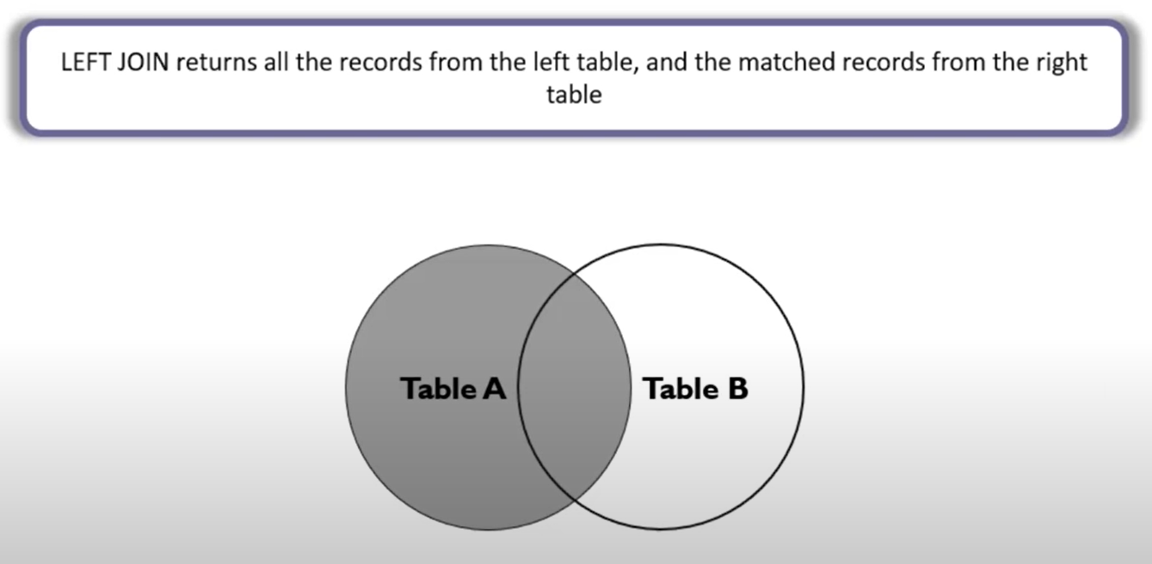

Syntax –

SELECT a.column_name, b.column_name
FROM table_name a LEFT JOIN table_name b
ON a.column_name = b.column_name;

OR

SELECT a.column_name, b.column_name
FROM table_name a, table_name b
WHERE a.column_name = b.column_name(+);

Example –

SELECT a.emp_id emp_id,
a.name emp_name,
b.emp_id details_emp_id,
b.address details_emp_address,
b.address_code details_emp_code
FROM emp_log a LEFT JOIN emp_details b
ON a.emp_id = b.emp_det_id;

SELECT a.emp_id emp_id,
a.name emp_name,
b.emp_id details_emp_id,
b.address details_emp_address,
b.address_code details_emp_code
FROM emp_log a, emp_details b
WHERE a.emp_id = b.emp_id(+);

To get the rows that are available only in the left table but not in the right table Then add a WHERE clause.

SELECT a.emp_id emp_id,
a.name emp_name,
b.emp_id details_emp_id,
b.address details_emp_address,
b.address_code details_emp_code
FROM emp_log a LEFT JOIN emp_details b
ON a.emp_id = b.emp_id
WHERE b.emp_id IS NULL;

SELECT a.emp_id emp_id,
a.name emp_name,
b.emp_det_id details_emp_id,
b.address details_emp_address,
b.address_code details_emp_code
FROM emp_log a, emp_details b
WHERE a.emp_id = b.emp_id(+)
AND b.emp_id IS NULL;

Left Join with three tables –

SELECT a.emp_id emp_id,
a.name emp_name,
b.emp_id details_emp_id,
b.address details_emp_address,
b.address_code details_emp_code,
c.add_code_name
FROM emp_log a
LEFT JOIN emp_details b ON a.emp_id = b.emp_id
LEFT JOIN address_code_name c ON c.add_code = b.address_code;

SELECT a.emp_id emp_id,
a.name emp_name,
b.emp_id details_emp_id,
b.address details_emp_address,
b.address_code details_emp_code,
c.add_code_name
FROM emp_log a, emp_details b, address_code_name c
WHERE a.emp_id = b.emp_id(+) and b.address_code = c.add_code(+);

- RIGHT Outer Join (RIGHT Join)–

- The RIGHT [OUTER] JOIN is the opposite of the LEFT [OUTER] JOIN.
- The right join returns all rows from the right table and the matching rows from the left table.
- If a row in the right table does not have a matching row in the left table, the columns of the left table will have nulls values.
- The right join is also known as right outer join. The outer keyword is optional.
- If you want to get only rows from the right table that do not exist in the left table. To achieve this, you use the right join and a WHERE clause to exclude the rows from the left table.
- A RIGHT OUTER JOIN returns all valid rows from the table on the right side of the JOIN keyword, along with the values from the table on the left side, or NULLs if a matching row doesn't exist.

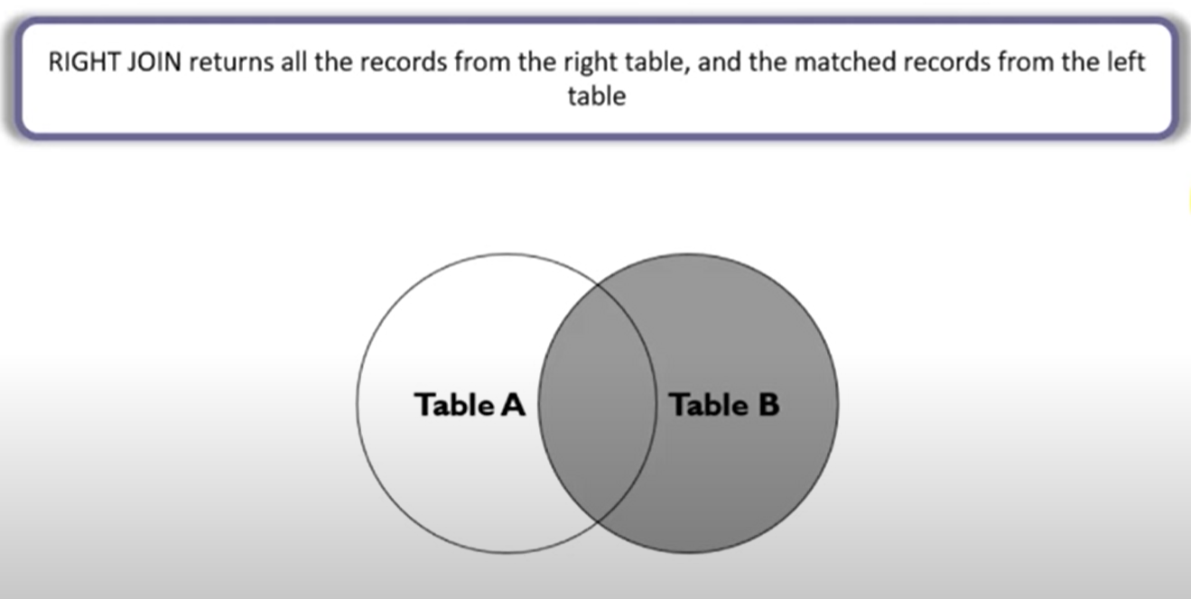

Syntax –

SELECT a.column_name, b.column_name
FROM table_name a RIGHT JOIN table_name b
ON a.column_name = b.column_name;

OR

SELECT a.column_name, b.column_name
FROM table_name a, table_name b
WHERE a.column_name(+) = b.column_name;

Example –

SELECT a.emp_id emp_id,
a.name emp_name,
b.emp_id details_emp_id,
b.address details_emp_address,
b.address_code details_emp_code
FROM emp_log a RIGHT JOIN emp_details b
ON a.emp_id = b.emp_id;

SELECT a.emp_id emp_id,
a.name emp_name,
b.emp_id details_emp_id,
b.address details_emp_address,
b.address_code details_emp_code
FROM emp_log a, emp_details b
WHERE a.emp_id(+) = b.emp_id;

To get the rows that are available only in the RIGHT table but not in the left table then add a WHERE clause.

SELECT a.emp_id emp_id,
a.name emp_name,
b.emp_id details_emp_id,
b.address details_emp_address,
b.address_code details_emp_code
FROM emp_log a RIGHT JOIN emp_details b
ON a.emp_id = b.emp_id
WHERE a.emp_id IS NULL;

SELECT a.emp_id emp_id,
a.name emp_name,
b.emp_id details_emp_id,
b.address details_emp_address,
b.address_code details_emp_code
FROM emp_log a, emp_details b
WHERE a.emp_id(+) = b.emp_id
AND a.emp_id IS NULL;

Right Join with three tables –

SELECT a.emp_id emp_id,
a.name emp_name,
b.emp_id details_emp_id,
b.address details_emp_address,
b.address_code details_emp_code,
c.add_code_name
FROM emp_log a
RIGHT JOIN emp_details b ON a.emp_id = b.emp_id
RIGHT JOIN address_code_name c ON c.add_code = b.address_code;

SELECT a.emp_id emp_id,
a.name emp_name,
b.emp_id details_emp_id,
b.address details_emp_address,
b.address_code details_emp_code,
c.add_code_name
FROM emp_log a, emp_details b, address_code_name c
WHERE a.emp_id(+) = b.emp_id
AND b.address_code(+) = c.add_code;

- FULL Outer Join (FULL Join) –

- Full outer join or full join returns a result set that contains all rows from both left and right tables, with the matching rows from both sides where available. If there is no match, the missing side will have null values.

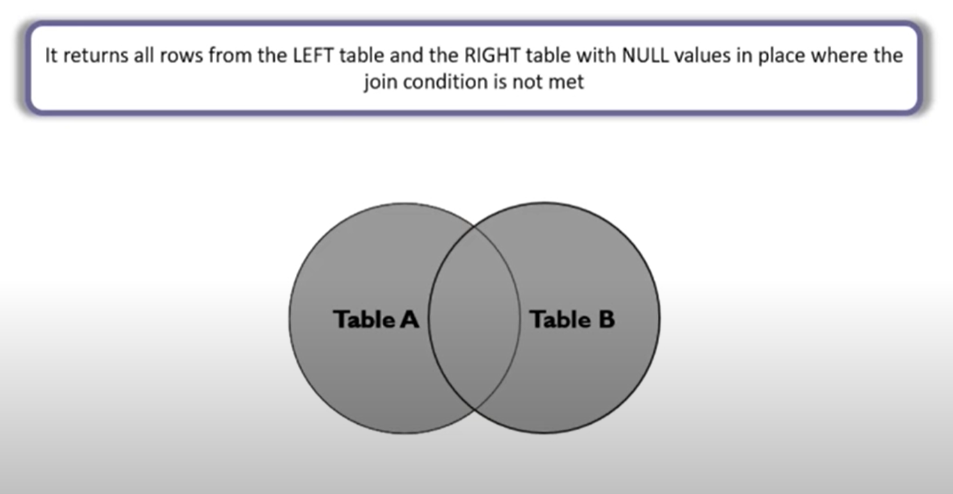

Syntax –

SELECT a.column_name, b.column_name
FROM table_name a FULL OUTER JOIN table_name b
ON a.column_name = b.column_name;

Example –

SELECT a.emp_id emp_id,
a.name emp_name,
b.emp_id details_emp_id,
b.address details_emp_address,
b.address_code details_emp_code
FROM emp_log a FULL JOIN emp_details b
ON a.emp_id = b.emp_id;

To get the rows that are not available in the LEFT as well as RIGHT table but then add a WHERE clause.

SELECT a.emp_id emp_id,
a.name emp_name,
b.emp_id details_emp_id,
b.address details_emp_address,
b.address_code details_emp_code
FROM emp_log a FULL JOIN emp_details b
ON a.emp_id = b.emp_id
WHERE a.emp_id IS NULL
OR b.emp_id IS NULL;

Full join with three tables -

SELECT a.emp_id emp_id,
a.name emp_name,
b.emp_id details_emp_id,
b.address details_emp_address,
b.address_code details_emp_code,
c.add_code_name
FROM emp_log a
FULL JOIN emp_details b ON a.emp_id = b.emp_id
FULL JOIN address_code_name c ON c.add_code = b.address_code;

- Equijoin –

- Equijoin returns the matching column values of the associated tables. It uses a comparison operator in the WHERE clause to refer equality.
- Equijoin also can be performed by using JOIN keyword followed by ON keyword and then specifying names of the columns along with their associated tables to check equality.
Difference between Inner Join and Equi Join?
- Inner join can have equality (=) and other operators (like <, >, <>) in the join condition.
- Equi join only have equality (=) operator in the join condition.
- Equi join can be an Inner join, Left Outer join, Right Outer join

Syntax –

SELECT a.column_name, b.column_name
FROM table_name a, table_name b
WHERE a.column_name = b. Column_name;

Example -

SELECT a.emp_id emp_id,
a.name emp_name,
b.emp_id details_emp_id,
b.address details_emp_address,
b.address_code details_emp_code
FROM emp_log a, emp_details b
WHERE a.emp_id = b.emp_id;

Equi Join with three tables –

SELECT a.emp_id emp_id,
a.name emp_name,
b.emp_id details_emp_id,
b.address details_emp_address,
b.address_code details_emp_code,
c.add_code_name
FROM emp_log a, emp_details b, address_code_name c
WHERE a.emp_id = b.emp_id
AND c.add_code = b.address_code;

- SELF Join –

- A self-join is a join that joins a table with itself. A self-join is useful for comparing rows within a table or querying hierarchical data.
- A self-join uses other joins such as inner join and left join. In addition, it uses the table alias to assign the table different names in the same query.
- Note - Referencing the same table more than once in a query without using table aliases cause an error.
- Self-Join is a specific type of Join. In Self Join, a table is joined with itself. A self-join simply specifies that each rows of a table is combined with itself and every other row of the table.

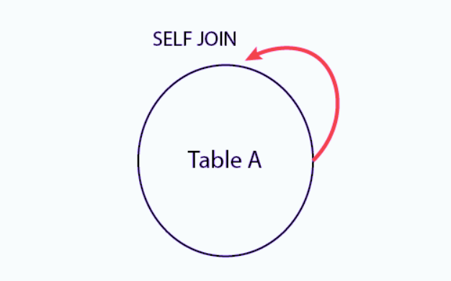
Syntax –

SELECT a.column_name, b.column_name...
FROM table1 a, table1 b
WHERE a.common_field = b.common_field;

OR

SELECT a.column_name, b.column_name...
FROM table1 a INNER JOIN table1 b
ON a.column_name > b.column_name;
AND a.column_name = b.column_name;

Example –

Example –

CREATE TABLE STUDY
(STD_ID VARCHAR2(10),
COURSE_ID VARCHAR2(10),
SINCE VARCHAR2(10));

INSERT INTO STUDY VALUES ('S1','C1',2016);
INSERT INTO STUDY VALUES ('S2','C2',2017);
INSERT INTO STUDY VALUES ('S1','C2',2017);

STUDY TABLE REFERRED AS T1 –

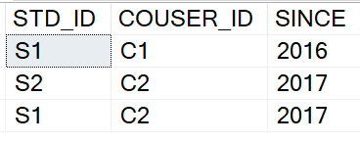

STUDY TABLE REFERRED AS T2 –

FOR EXAMPLE USING CROSS JOIN OUTPUT WILL BE -

SELECT T1.STD_ID, T1.COURSE_ID, T2.STD_ID, T2.COURSE_ID
FROM STUDY T1, STUDY T2;

OUTPUT OF CROSS JOIN -

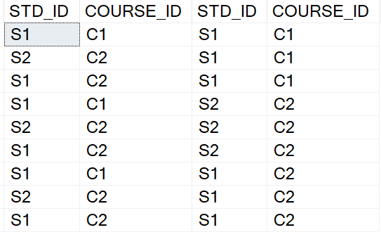

Want Those Record Whose Student_Id Is Same But Course Id Is Different -

SELECT T1.STD_ID, T1.COURSE_ID, T2.STD_ID, T2.COURSE_ID
FROM STUDY T1, STUDY T2
WHERE T1.STD_ID = T2.STD_ID
AND T1.COURSE_ID <> T2.COURSE_ID;

Example –

CREATE TABLE EMPMAN
(EMP_ID NUMBER,
NAME VARCHAR2(10),
MAN_ID NUMBER);

INSERT INTO EMPMAN VALUES (1,'RAHUL',3);
INSERT INTO EMPMAN VALUES (2,'JAY',3);
INSERT INTO EMPMAN VALUES (3,'SONAM',4);
INSERT INTO EMPMAN VALUES (4,'KUNAL',5);
INSERT INTO EMPMAN VALUES (5,'AMOL',NULL);

EMPMAN TABLE REFERRED AS E -

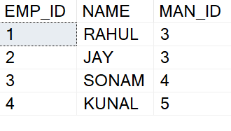
EMPMAN TABLE REFERRED AS M –

FOR EXAMPLE USING CROSS JOIN OUTPUT WILL BE -

SELECT E.NAME NAME, M.NAME MANAGER
FROM EMPMAN E, EMPMAN M;

OUTPUT OF CROSS JOIN -

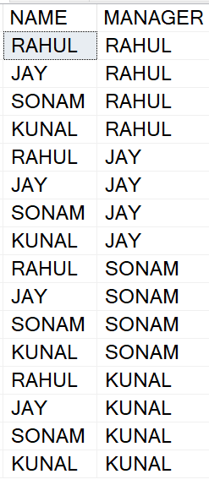

WANT TO FIND RECORD OF EMPLOYEE AND HIS MANAGER USING INNER JOIN -

SELECT E.NAME NAME, M.NAME MANAGER
FROM EMPMAN E INNER JOIN EMPMAN M
ON E.MAN_ID = M.EMP_ID;

WANT RECORD OF EMPLOYEE AND HIS MANAGER USING LEFT JOIN -
SELECT E.NAME NAME, M.NAME MANAGER
FROM EMPMAN E LEFT JOIN EMPMAN M
ON E.MAN_ID = M.EMP_ID;

Using Self-join to query hierarchical data –
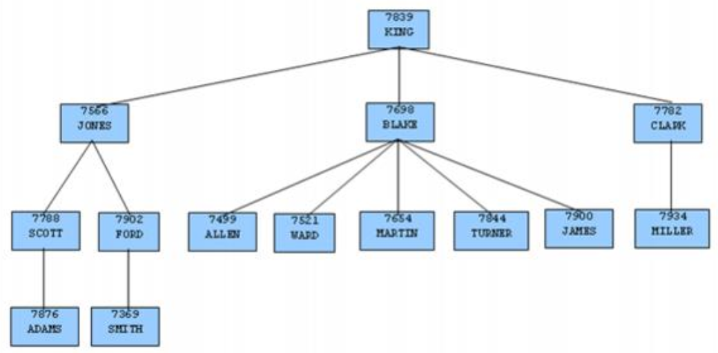

- Cross join –

- A cross join is the deliberate creation of a Cartesian product. There are no join columns specified, so every possible combination of rows between the two tables is produced.
- To create a Cartesian product of tables, you use the cross join clause.
- Unlike other joins such as inner join or left join, cross join does not have the on clause with a join predicate.
- When you perform a cross join of two tables, which have no relationship, you will get a Cartesian product of rows and columns of both tables.
- The cross join is useful when you want to generate plenty of rows for testing.
- Suppose we have two tables that have m and n rows, the Cartesian product of these tables has m x n rows.

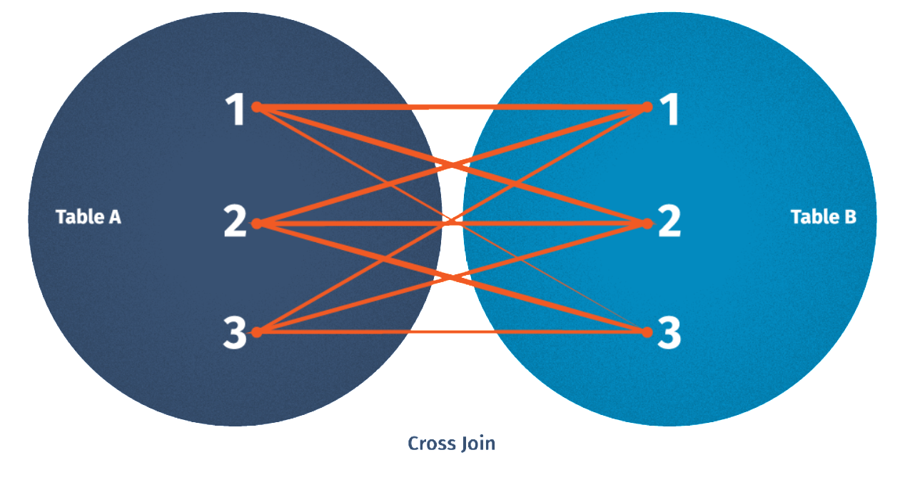

Syntax –

SELECT a.column_name, b.column_name
FROM table1 a CROSS JOIN table2 b;

OR

SELECT * FROM table1, table2

Example –

SELECT a.emp_id "Employee id",
a.name "Employee name",
b.emp_id "Details emp id",
b.address "Details emp address",
b.address_code "Details emp code"
FROM emp_log a CROSS JOIN emp_details b
ORDER BY a.emp_id;

SELECT a.emp_id "Employee id",
a.name "Employee name",
b.emp_id "Details emp id",
b.address "Details emp address",
b.address_code "Details emp code"
FROM emp_log a, emp_details b
ORDER BY a.emp_id;

SELECT * FROM emp_log , emp_details;

- Natural join –

- A natural join is a variant on an inner join. The join columns are determined implicitly, based on the column names. Any columns that share the same name between the two tables are assumed to be join columns.
- Using a natural join is a bad idea. If someone adds a new column to one of the tables that happens to have the same name as a column in the other table, they may break any existing natural joins. It is effectively a bug waiting to happen.

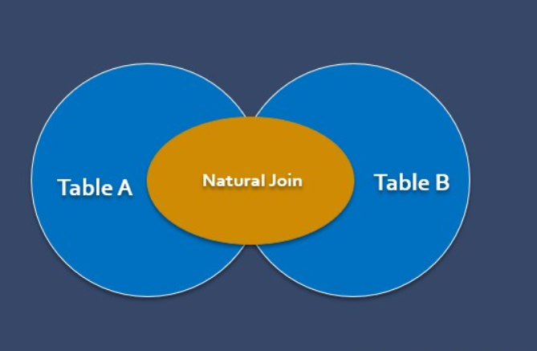

Syntax –

SELECT column_names
FROM table1 a NATURAL JOIN table2 b;

Example –

SELECT emp_id, name emp_name,
address details_emp_address,
address_code details_emp_code
FROM emp_log a NATURAL JOIN emp_details b;

__________________________THANK YOU____________________________

